Grad Hoodies Order Form
Your Name:______________________________
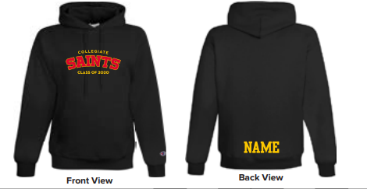
Homeroom teacher:_______________________

Pricing: Please check which one you are ordering. Cash due at time of order.
Also available through School Cash online.
- $50 - Embroidered “Collegiate Saints – Class of 2020”
or
- $63 - Embroidered “Collegiate Saints – Class of 2020” with name on back
If you selected $63 option, what name do you want on the back of the sweater?
Please print clearly! ____________________________
Size:__________________________
Sizes available Small – 3XL
Sweatshirts are unisex sizing.

