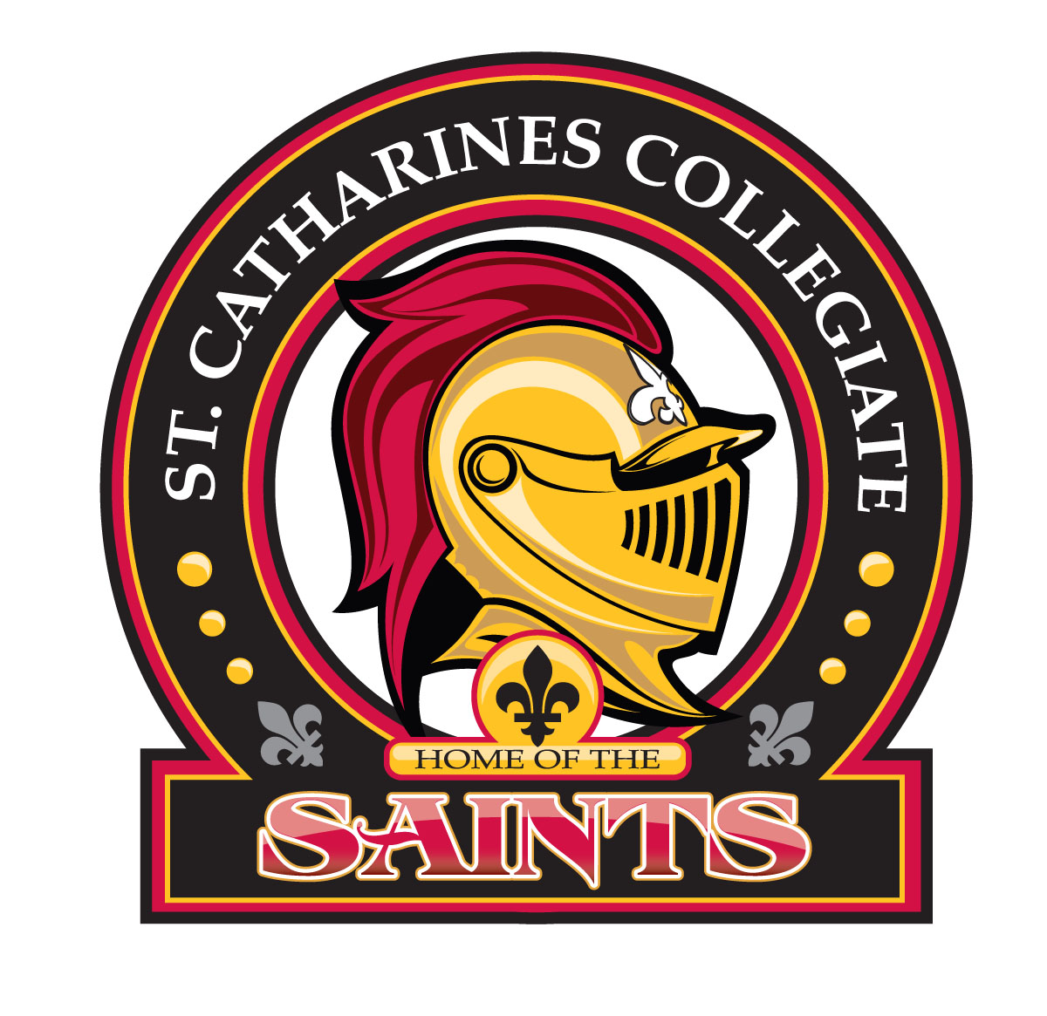 St. Catharines Collegiate
2019 Grad Hoody


Price: $56.00 total (including taxes)
If ordering 3XL or 4XL add an additional $3.00 for total of $59.00

Student Name: _____________________________________

Name you want to have on the back of hoody: ___________________

XS | Small | Med | Large | XLarge | 2XL | 3XL | 4XL | Total Price:
Can be paid using SchoolCash online or with cash only. Return the order form to the office by December 19, 2018.

